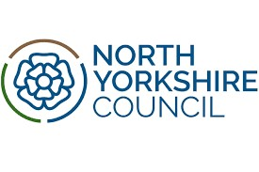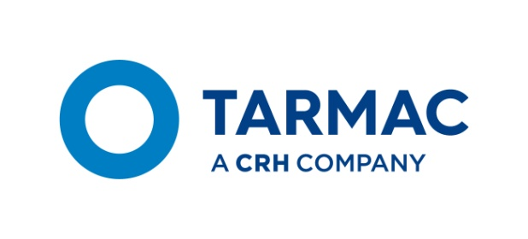1

North Yorkshire Council

Customer Service Centre

County Hall

Northallerton

DL7 8AD

Tel: 0300 131 2 131

Email: [Customer.services@northyorks.gov.uk](mailto:Customer.services@northyorks.gov.uk)

Web: www.northyorks.gov.uk

12 September 2024

Dear Resident/Proprietor

**CARRIAGEWAY RESURFACING WORKS – C181 BLUE HILL, WHITWELL ON THE HILL**

This letter is to inform you that Tarmac, on behalf of North Yorkshire Council, will be undertaking essential carriageway maintenance works at the above location.

The works are currently programmed to commence on Thursday 26 September 2024 and will be carried out under a full road closure between the hours 07:30 and 17:00 for approximately 7 days Monday to Friday only. The road will be open outside of these hours.

The work will be carried out in two phases. Work on the East side of the river will be carried out between 26 September and 04 October 2024. Work on the West side of the river will be carried out between 02 October and 04 October 2024.

A plan showing the extent of the work and the diversion route is shown overleaf. Advance warning signage advising of the works will be installed on site shortly.

On-site personnel will assist in managing access to properties within the closure however, please be advised that there may be extended periods when vehicular access will not be possible due to the nature of the works and the physical constraints of the site. Pedestrian access will be maintained.

If you usually park your vehicle on the carriageway within the work extents, please make arrangements to park your vehicle at an alternative location.

Please note that this work is part of an extensive programme and therefore it is possible that some adjustment to this start date, or works duration, may be necessary should unforeseen circumstances arise, such as the requirement for additional works, significant weather events or emergencies on the highway network.

If you have any queries regarding the works or to notify us of any special access requirements, please contact the Traffic Management Team during the day on 01977 301813 or 0330 043 3030 out of hours. Alternatively, please contact the NY Customer Service Centre on 0300 131 2 131.

Please co-operate and comply with any instructions issued by the traffic management operatives and take extra care whilst works are in progress.

May I draw your attention to the Council’s Corporate Privacy Policy by using the following link <https://www.northyorks.gov.uk/privacy-notices>. When submitting a response, we will record personal information including your name and address.

For further information, including diversion information and to sign up for alerts please go to;

<https://www.northyorks.gov.uk/roadworks>

I would like to take this opportunity to apologise for any disruption that these works may cause and would again request your co-operation to help ensure that the project can be executed efficiently and safely.

Yours faithfully

Customer Service Centre

North Yorkshire Council

**Work location, extent and closure (red) and diversion (blue)**

